ASSIGNMENT

Contents
REGISTERS 2
Lab 01: Familiarity with 8086 Emulator 5
Lab 02: ASSEMBLY CODE 9

Name: Muhammad Abrar
Class: BS-Software Engineering (4B-Morning)
Arid Number: 24-ARID-1039

REGISTERS
A register is a small bit of memory that sits inside the CPU and is used by assembly language to perform various tasks.
The 8086 has four general data registers the address registers are divided into segment, pointer
TYPES
1. General Purpose Registers
Used to store data and perform operations.
Register | Use
AX | Accumulator (math operations)
BX | Base register (addressing)
CX | Counter (loops)
DX | Data register
Each register is 16-bit and can be split into:
AX AH (High byte)
AX AL (Low byte)
2. Segment Registers
Used to access different memory segments.
Register | Meaning
CS | Code Segment
DS | Data Segment
SS | Stack Segment
ES | Extra Segment
3. Pointer & Index Registers
Register | Purpose
SP | Stack Pointer
BP | Base Pointer
SI | Source Index
DI | Destination Index
Used for arrays, strings, stack operations.
4. Flag Register
Stores status flags after operations.
Flag | Meaning
ZF | Zero Flag
CF | Carry Flag
SF | Sign Flag
OF | Overflow Flag
Common 8086 Registers.
1)AX (Accumulator)
Used for arithmetic operationse.g MOV AX, 5
2)BX (Base Register) Used to store base addresses e.g MOV BX, 2000H
3)CX (Count Register)
Used for loops/countinge.g MOV CX, 10
4)DX (Data Register)
Used for I/O and multiplication e.g MOV DX, 03F8H
5)SP (Stack Pointer)
Points to top of stacke.gMOV SP, 1000H
6) BP (Base Pointer)
Accesses stack datae.g MOV BP, SP
7) SI (Source Index)
Source for string operations e.g MOV SI, 0200H
8)DI (Destination Index)
Destination for string ops e.g MOV DI, 0300H
9) IP (Instruction Pointer)
Holds address of next instruction e.g(updated automatically)
10)FLAGS Register
Stores status flags e.gJC LABEL (checks Carry Flag)
INPUT AND OUTPUT Processes
Input Processes
- AL
Stores input character from keyboardINT 21H (AH = 01H, result in AL)
- DX
Holds port number for input IN AL, DX
Output Processes
- DL
Holds character to displayINT 21H (AH = 02H, DL = 'A')
- DX
Holds port number for output OUT DX, AL
Control Registers (for I/O services):
- AH
Selects I/O function MOV AH, 01H (keyboard input)
- AL
Carries I/O data MOV AL, 65

Lab 01: Familiarity with 8086 Emulator
This section elaborates the environment of software tool to be used in LAB. Note that actually you may use an updated version of the software tool.

- Start Emu8086 by selecting its icon from the start menu, or by running
- Emu8086.exe.
- Select "Samples" from "File" menu.
- Click [Compile and Emulate] button (or press F5 hot key).
- Click [Single Step] button (or press F8 hot key), and watch how the codeis being executed.
Step 1:
- Click on start
- Type “emu8086”
- Click on the icon as shown in figure 1

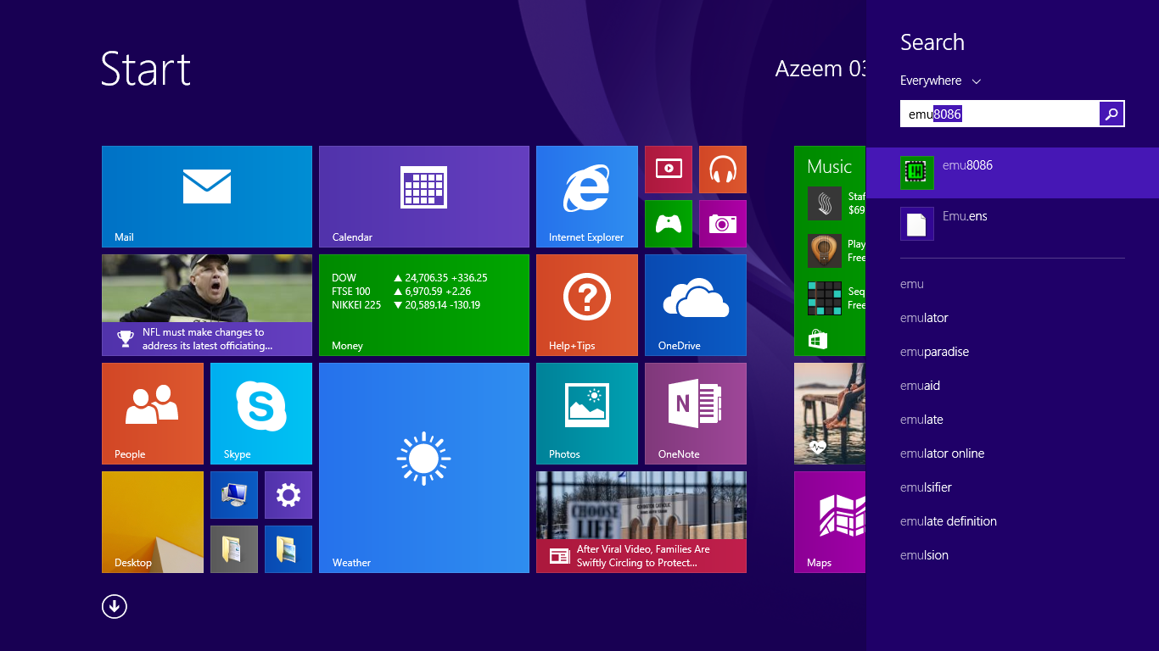

Figure 1
Step 2:
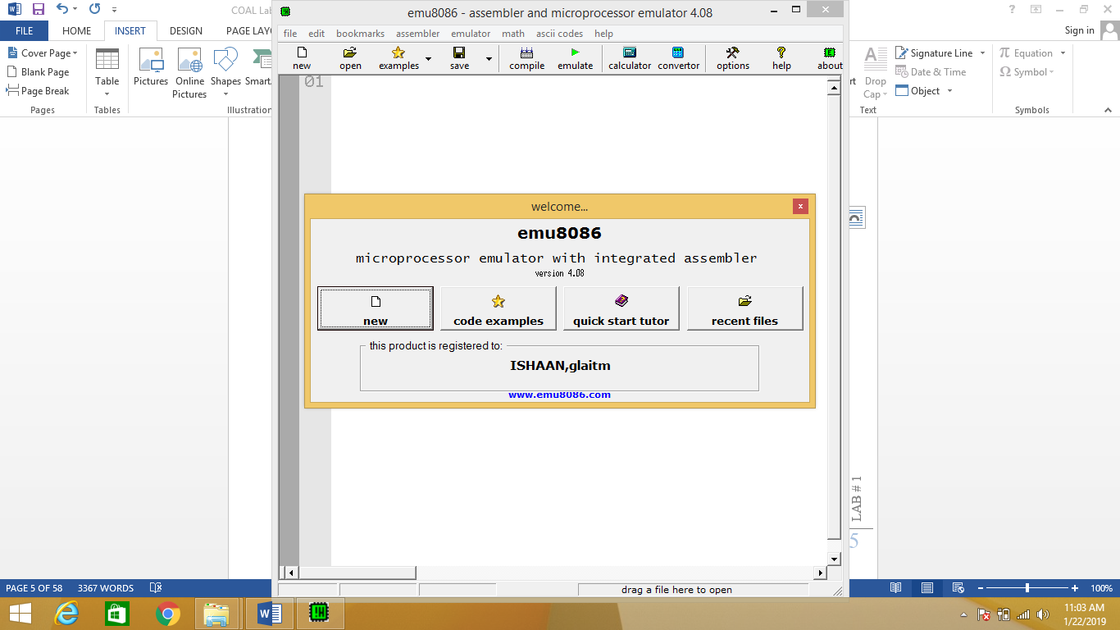
Figure 2
Step 3:
- Basic Structure
- And emulate

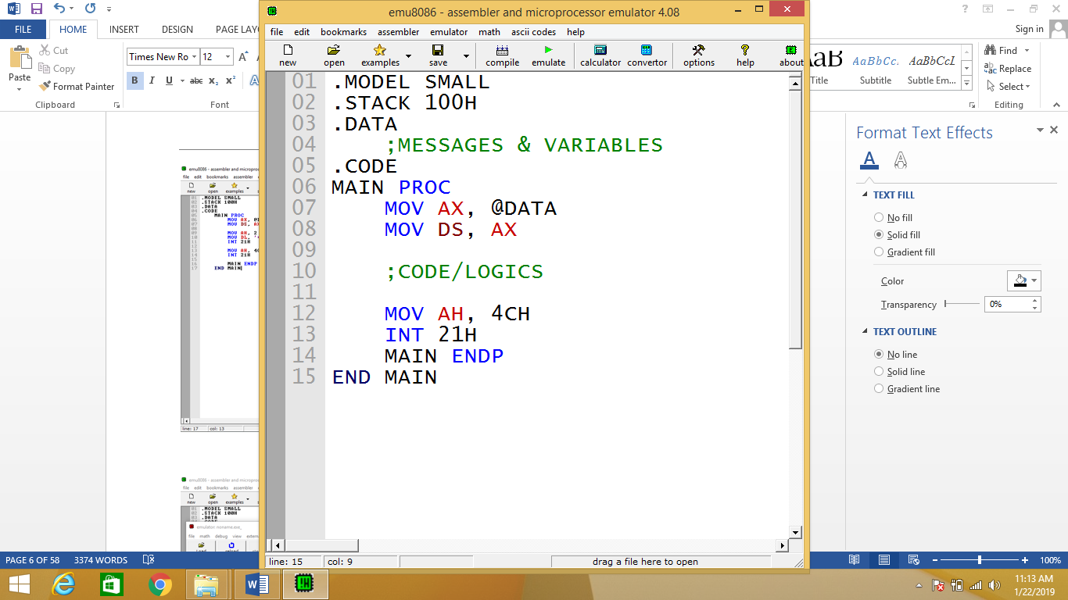

Figure 3

Step 4:
- Run
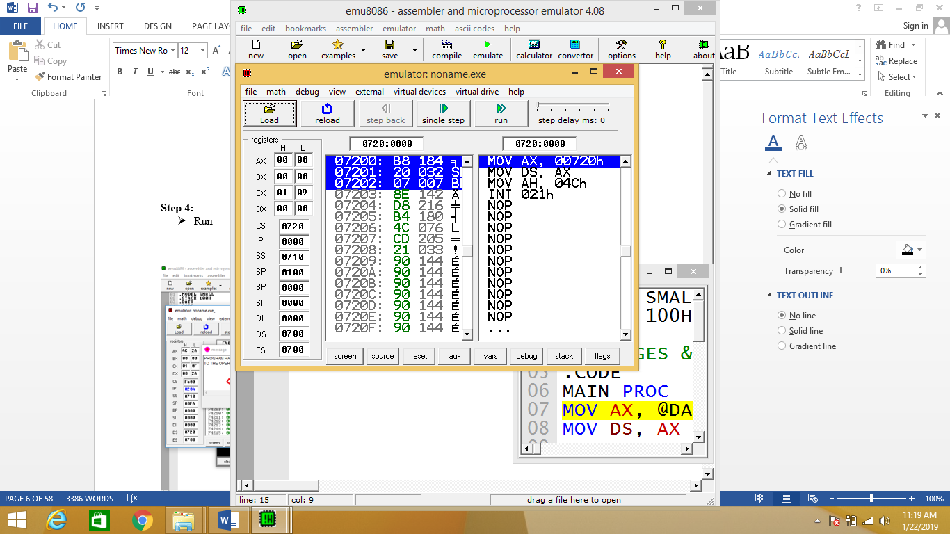

Figure 4
Step 5:
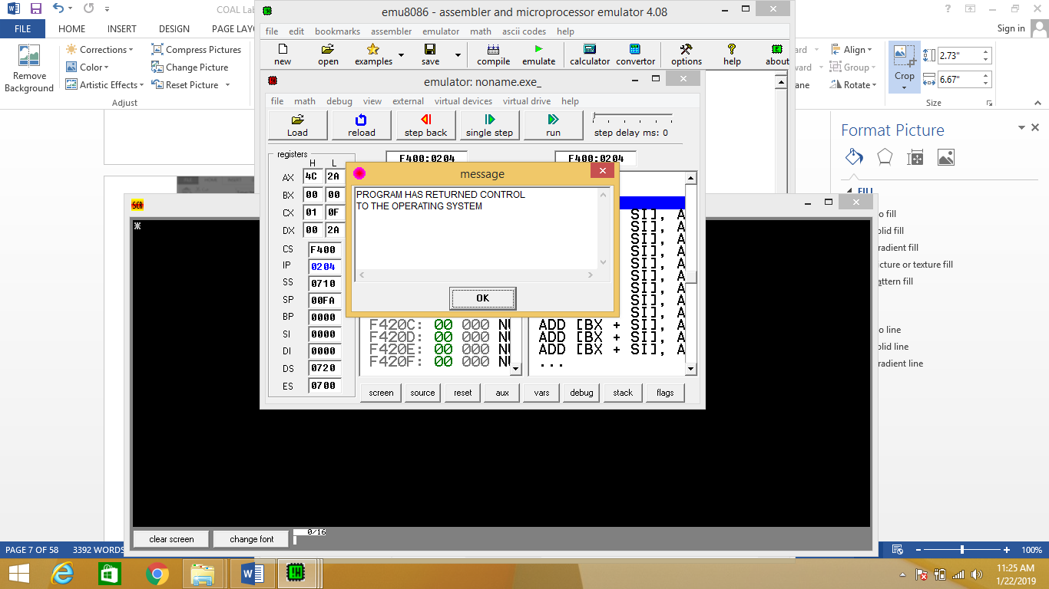

Figure 5

Step 6:
- Output

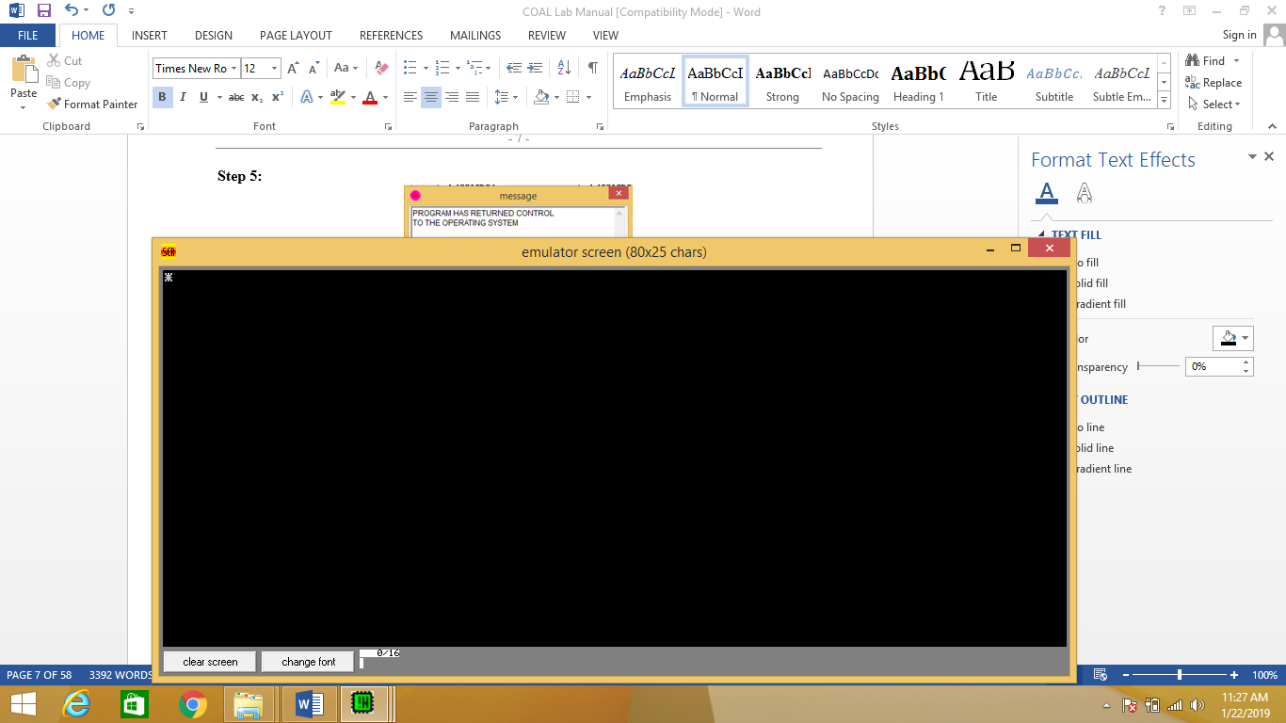

Figure 6

Lab 02: ASSEMBLY CODE
Write a complete program to do the following.
- Write a code that will input a character from user and will display it on the same line at next position.
- Write a code that will input an uppercase letter from user and will display it at next position on the same line.
Solution:
a) Write a code that will input a character from user and will display it on the same line at next position.
CODE:
.MODEL SMALL ; SMALL memory model (one code, one data)

.STACK 100H ; Allocate stack of 256 bytes (100H)

.DATA ; Start of DATA segment
MSG DB 'ENTER A CHARACTER: $' ; Message string ending with '$'

.CODE ; Start of CODE segment
MAIN PROC ; MAIN procedure begins (entry point)

MOV AX, @DATA ; Move DATA segment address into AX
MOV DS, AX ; Move AX value into DS (initialize data segment)

MOV AH, 09H ; AH = 09H (DOS function to display string)
LEA DX, MSG ; Load Effective Address of MSG into DX
INT 21H ; Call DOS interrupt to display message

MOV AH, 01H ; AH = 01H (DOS function to input character)
INT 21H ; Read character from keyboard into AL

MOV DL, AL ; Move input character from AL to DL
MOV AH, 02H ; AH = 02H (DOS function to display character)
INT 21H ; Display character on screen

MOV AH, 4CH ; AH = 4CH (DOS function to terminate program)
INT 21H ; Terminate program execution

MAIN ENDP ; End of MAIN procedure
END MAIN ; End of program
b) Write a code that will input an uppercase letter from user and will display it at next position on the same line
CODE:
.MODEL SMALL ; SMALL memory model definition

.STACK 100H ; Allocate 256 bytes stack memory

.DATA ; DATA segment begins
MSG DB 'ENTER UPPERCASE LETTER: $' ; Prompt message

.CODE ; CODE segment begins
MAIN PROC ; MAIN procedure starts

MOV AX, @DATA ; Load DATA segment address into AX
MOV DS, AX ; Initialize DATA segment register DS

MOV AH, 09H ; Select DOS function to display string
LEA DX, MSG ; Load address of MSG into DX
INT 21H ; Display message using DOS interrupt

MOV AH, 01H ; Select DOS function to read character
INT 21H ; Read character into AL register

MOV DL, AL ; Transfer character from AL to DL
MOV AH, 02H ; Select DOS function to display character
INT 21H ; Display character on screen

MOV AH, 4CH ; Select DOS function to exit program
INT 21H ; Terminate execution

MAIN ENDP ; End of MAIN procedure
END MAIN ; End of program

